revenue & Profit Analysis

- Calculate the overall Profit Margin (%) for the company and determine whether a 12.47% margin is healthy for a retail business. Support your answer with data.
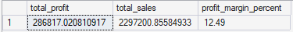

- Create a Category Performance Report showing Sales, Profit, Profit Margin (%), and Contribution to Total Revenue. Rank categories based on profitability rather than sales.
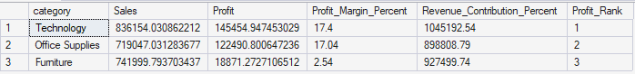

- Technology generates the highest revenue and profit. Identify the key factors responsible for its superior performance compared to Furniture and Office Supplies.
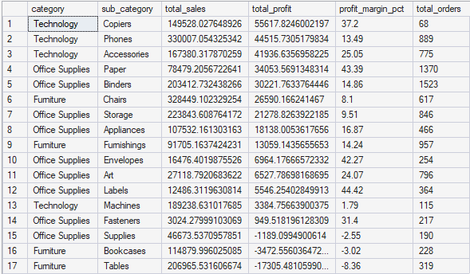

Category & Sub-Category Analysis

- Create a Sub-Category Profitability Matrix and identify which sub-categories are destroying overall company profit.
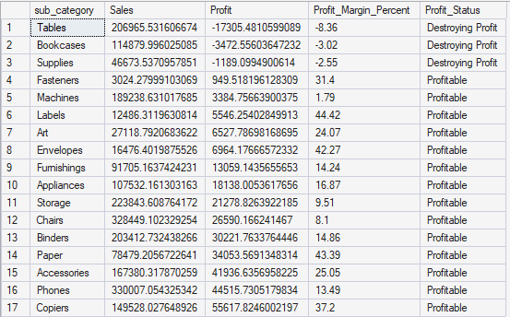

5. Tables generated a loss of over $17,000. Analyze:

Average Discount
Average Sales
Number of Orders
Profit Margin
and determine the root cause of losses.

6. Compare Tables and Bookcases with the top three profitable sub-categories. What operational or pricing differences exist?
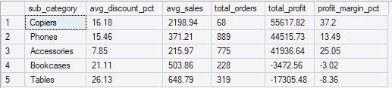
Discount Impact Analysis

7. Categorize discounts into:

0%
0–20%
20–40%
Above 40%

Calculate Sales, Profit, Profit Margin, and Order Count for each group.
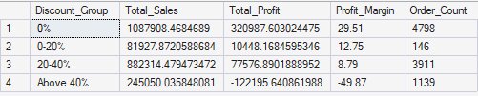

8. Determine the exact financial impact of discounts above 40% on company profitability.
9. Create a chart showing the relationship between Discount % and Profit. Explain whether higher discounts consistently lead to lower profits.
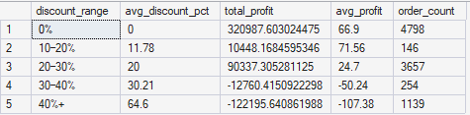
10. If management limits discounts to a maximum of 30%, estimate the potential improvement in profitability.
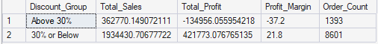

Regional Analysis

11. Create a Regional Scorecard showing:

Sales
Profit
Profit Margin
Average Discount
Return Rate
Identify the strongest and weakest region.
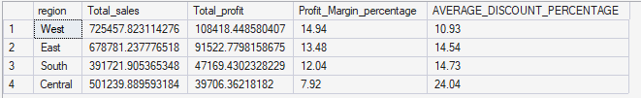
12. The West region leads in sales and profit. Determine whether its success comes from higher sales volume, better margins, lower returns, or a combination of factors.
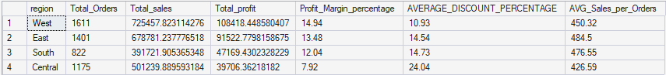
State-Level Analysis

13. Analyze Texas, Ohio, and Pennsylvania in terms of:

Total Sales
Total Profit
Average Discount
Returned Orders
Loss-Making Products

Explain why these states generate heavy losses.
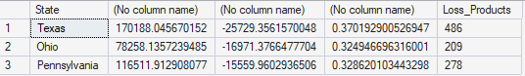
14. Create a Top 10 and Bottom 10 States dashboard and provide recommendations for improving performance in loss-making states.
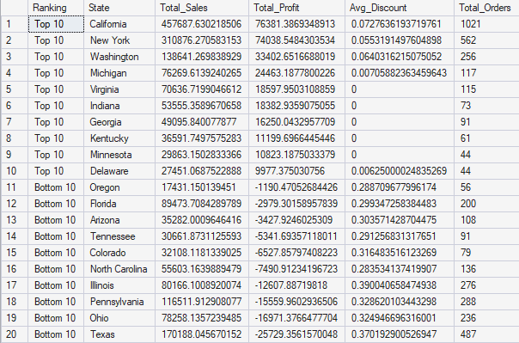
Growth Analysis

15. Calculate Year-over-Year Sales Growth and Profit Growth. Explain why sales growth has outpaced profit growth.
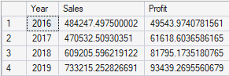
16. Identify whether increasing sales volume is actually improving business performance or simply increasing low-margin transactions.
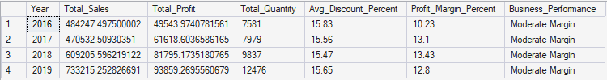
Returns Analysis

17. Using the Returns sheet, calculate:
Return Rate (%)
Returned Sales Value
Returned Profit Impact
Assess the financial risk posed by returns

18. Identify which Categories, Sub-Categories, and Regions contribute most to returned orders. Provide recommendations to reduce returns.
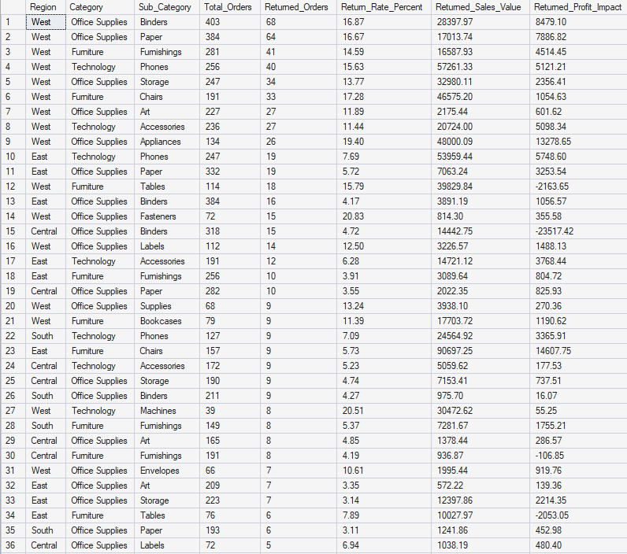
Dashboard & Decision Making

19. Build an Executive Dashboard containing:
Total Sales
Total Profit
Profit Margin
Return Rate
Top Category
Worst Category
Top State
Most Loss-Making State
Sales Trend
Explain why each KPI is important for management.
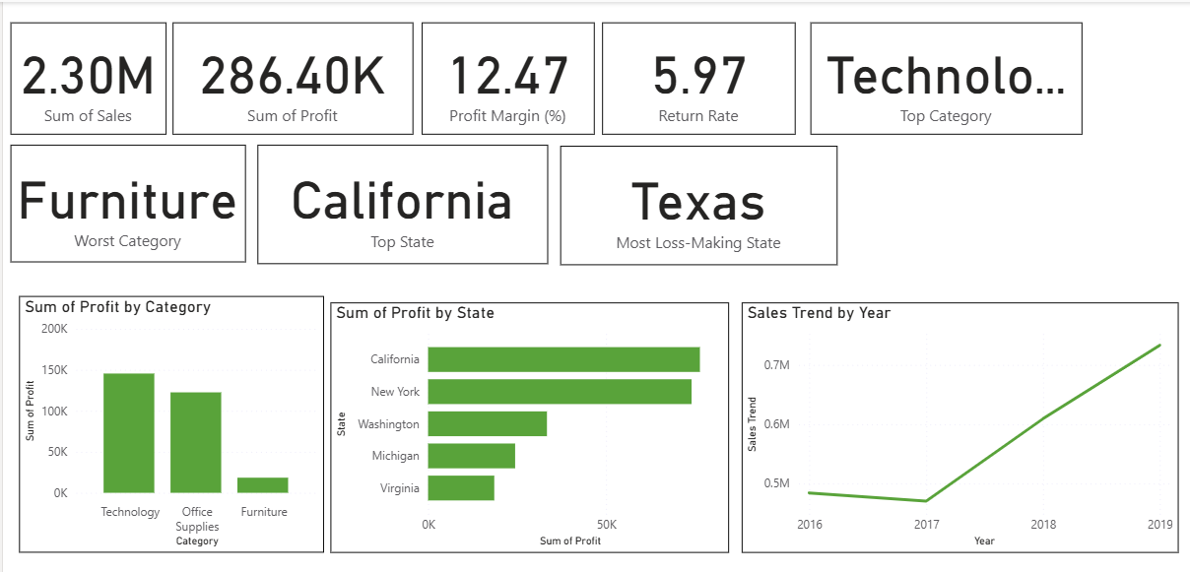

20. You have been hired as a Business Analyst. Based on the complete dataset, provide:
Top 5 Business Problems
Top 5 Opportunities
Top 5 Recommendations
Support every recommendation with quantitative evidence from the data.

Top 5 Business Problems
1. Deep discounting is destroying profit: Orders with a discount of 30% or more (1,393 order lines) generated a combined loss of -$135,376 on $362,770 of sales, while orders discounted below 30% earned $421,773 in profit. The overall correlation between Discount and Profit is -0.22, confirming that heavier discounting is systematically linked to lower profitability.
2. Furniture — especially Tables and Bookcases — is chronically unprofitable: The Furniture category has the weakest margin of any category at just 2.49%. Within it, Tables lost -$17,725 on $206,966 in sales (-8.56% margin, 307 orders) and Bookcases lost -$3,473 (-3.02% margin). Tables also carry an average discount of 26.1%, well above the company-wide average of 15.6%, directly linking the loss to over-discounting.
3. The Central region underperforms on profitability despite solid sales: The Central region posts the lowest profit margin of any region at 7.92%, versus 14.94% in the West and 13.48% in the East, on comparable sales ($501,240). Central also carries the highest average discount rate of any region (24.0% vs 10.9%-14.7% elsewhere), pointing to discounting as the likely driver of the underperformance.
4. A small number of high-value SKUs are large, concentrated loss-makers: Specific products are responsible for outsized losses: the Cubify CubeX 3D Printer (Double Head) lost -$8,880 on just 3 orders, the Lexmark MX611dhe printer lost -$4,590 on 4 orders, and the Cubify CubeX 3D Printer (Triple Head) lost -$3,840 on a single order. These few SKUs alone account for over $17,000 in losses.
5. Returns are concentrated in Technology and represent real economic loss: Returned orders across the business total $180,504 in sales and $23,232 in associated profit. Technology accounts for the largest share of this at $72,708 in returned sales and $13,997 in returned profit — the highest of any category — despite Technology otherwise being the top overall performer.

Top 5 Opportunities
1. Several Office Supplies sub-categories carry very high margins and room to grow: Labels (44.4% margin), Paper (43.4% margin on $78,479 sales), Envelopes (42.3% margin), and Fasteners (31.4% margin) are all far above the company average of 12.47%. These are low-risk, high-return product lines that are currently a small share of total sales and could be scaled up profitably.
2. Technology's Copiers sub-category is a standout high-margin performer: Copiers generate a 37.2% profit margin on $149,528 in sales ($55,618 profit) — the best-performing Technology sub-category by far — making it a strong candidate for increased marketing investment and inventory prioritization.
3. Overall sales are on a strong, consistent growth trajectory: Company-wide sales grew from $484,247 in 2014 to $733,215 in 2017, a 51.4% increase over four years. This sustained upward trend suggests market demand is expanding and supports the case for further investment in growth, provided profit leaks (discounting, Furniture losses) are fixed first.
4. The West and East regions are proven, high-margin markets worth expanding: West (14.94% margin, $725,458 sales) and East (13.48% margin, $678,781 sales) outperform Central and South on profitability while already carrying the largest sales volumes, making them strong candidates for continued or increased investment.
5. Home Office is the most profitable customer segment: The Home Office segment earns a 14.03% margin — the highest of the three segments — ahead of Corporate (13.03%) and Consumer (11.55%), despite having the smallest sales base ($429,653). Targeted marketing to grow this segment could lift overall company margin.

Top 5 Recommendations
1. Cap discounts at 20% on Furniture, and review all discounts above 30% company-wide: Evidence: orders discounted 30%+ produced a net loss of -$135,376; the 0-20% discount band was the only clearly healthy bracket, and Tables' -8.56% margin is tied to its 26.1% average discount, far above the 15.6% company average. Tightening discount approval above these thresholds would directly convert an existing loss into profit.
2. Renegotiate pricing or discontinue chronic loss-making Furniture sub-categories: Evidence: Tables (-$17,725 profit) and Bookcases (-$3,473 profit) together lost over $21,000 despite $321,845 in combined sales. Either raising base prices, reducing discount eligibility, or delisting the worst-performing SKUs (e.g., Chromcraft Bull-Nose tables at -$2,876) would stop the bleeding in this category.
3. Investigate and correct Central region's discounting practices: Evidence: Central's average discount (24.0%) is far above every other region, and its margin (7.92%) is roughly half that of the West (14.94%) on similar sales volume. Bringing Central's discounting in line with East/West norms could recover several percentage points of margin on $501,240 in sales.
4. Shift marketing and inventory investment toward proven high-margin lines: Evidence: Labels (44.4%), Paper (43.4%), Envelopes (42.3%), and Copiers (37.2%) all deliver margins 2.5-3.5x the company average of 12.47%. Reallocating a portion of Furniture-focused marketing spend toward these lines would improve blended profitability without requiring new sales volume.
5. Set up root-cause review for Technology returns: Evidence: Technology returns account for $72,708 in returned sales and $13,997 in returned profit — the highest of any category — even though Technology is otherwise the top overall profit generator ($145,455). Reducing Technology's return rate even modestly would protect a disproportionate share of the company's most valuable profit stream.

